RAYGINA PHOA

51020008

CLOUD COMP.PRAK HADIAH

1. Sri widjayanti

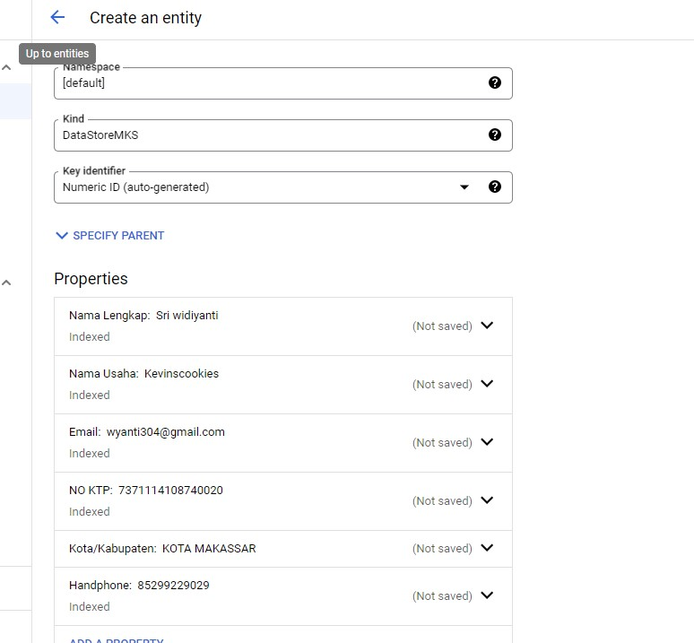

Hasilnya

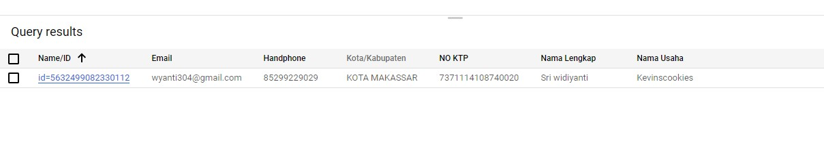

1. 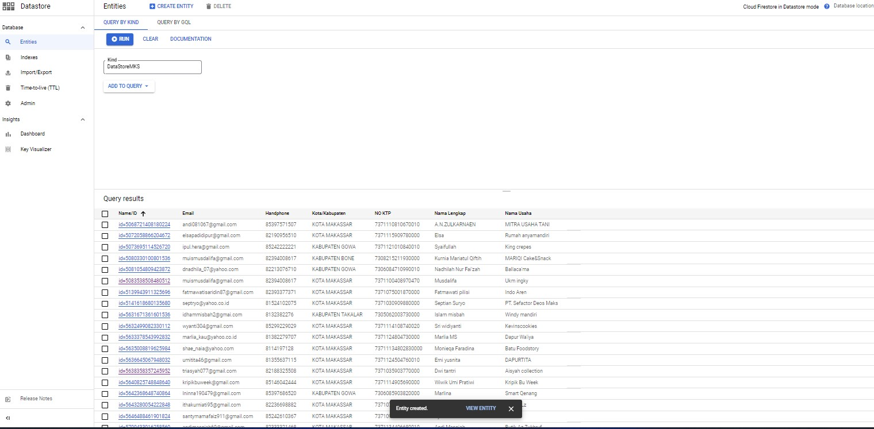
2. RUN QUERRY

